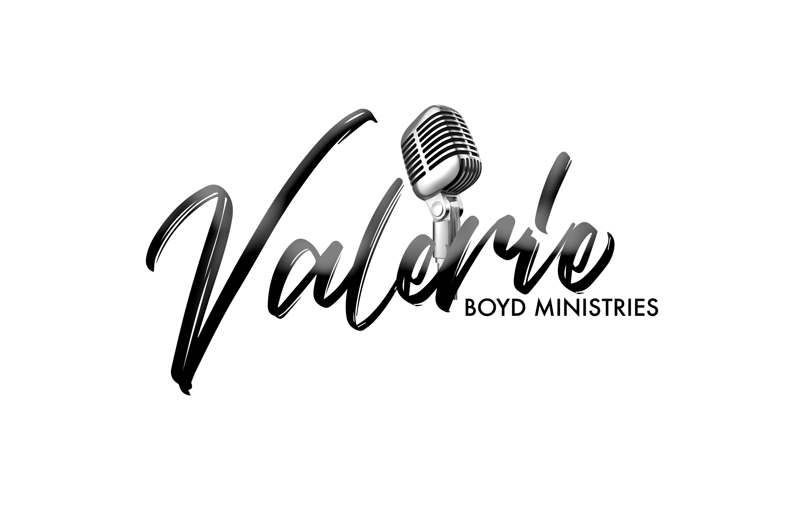
Booking Information Sheet

Thank you for your invitation we are truly honored. The following is a list of questions that we ask you read and answer in its entirety in order to better serve you.

- REPRESENTATIVE CONTACT INFORMATION

Name of Church:
Street Address:
State, Zip code:
Pastor’s Name:
Coordinator: Phone:
Is text messaging a convenient method of communication?

- EVENT INFORMATION:

Type of Event (i.e. Concert, Service, Conference, Retreat, etc.):
Attire (formal, semi-formal, casual, etc.):
Age Group /Demographic of Audience:
Name of Contact: Phone:
Event Theme:
Date(s) of Event:
Venue Name:
Duration Time:

Address: City:
State: Zip Code:
Venue Capacity:
Estimated Attendance:
Host Website:
Is this a ticketed/ Registration event?
If yes, what is the ticket or registration costs:
Please explain to us your events purpose and vision:
Please list Other Invited Guest(s)/Artist(s)/ Speaker (s):

- SERVICE REQUEST:

How did you hear about Valerie Boyd ministry?

Please circle your Ministerial request (s) below:

Actress, Psalmist, Speaker, Mistress of Ceremonies, Panelist, Other-Explain

Please Note:
For All Psalmist request please check off one of the following 3 options below:

- Option 1: Tracks (must have equipment to play tracks)

- Option 2: Live Band (Incl. Bass Player, Keyboard, and Drummer)

- Option 3: Live Band & Background Vocalists (Incl live band and 3 singers)

For Speaking Engagements please check off the appropriate options:

- Option 1: Is praying for individuals permitted?
- Option 2: Is the Speaker required to raise an offering?
- Option 3: Will the Speaker be required to give an altar call?

- SERVICE INFORMATION:

Duration time for Ministering (i.e. 10, 30, 45 mins etc.):
Performance start time:
Available equipment/instruments for event (i.e. amplifiers, keyboard(s), drum set, no.
of mics, etc.):

Is the Venue Equipped for MP3/tracks?

Budget allotted based on employer’s request:

- SOUND INFO:

Name of Sound Technician:

Phone:
Email:

- Media:

Medium of advertisement being used?

Will this event be video taped: Yes No

- ACCOMMODATIONS:

Can product (CDs, Clothing Apparel, etc.) be sold at this Event: Yes No

REQUESTS:
Reserved Parking Spot (Yes, No):

Private holding area before ministering (Yes, No):
Amenities: (Hot tea/ bottled water/ Ginger ale/ Fruit/ or meal)

FINANCIAL AGREEMENT

At the acceptance of this invitation Fifty Percent (50%) of the agreed honorarium must be received 30-60 days before the Event to hold the date; the remaining Fifty Percent (50%) must be received before service is rendered on the day of Event. Should the Event be cancelled for any reason be it natural disasters, illness of parties, etc. Payments made prior to services rendered will not be refunded unless agreed upon by both parties

- MISCELLANEOUS:

A Biography and Promotional Picture will be sent for any event flyers and other promotional material once invitation is CONFIRMED.

Please enclose any additional information you think we should know about your Event, Church, and or Organization Protocol, Any special information, etc.

Please send all promotional material (Flyers, Videos, etc.) to the Administrative Team at evgvalerieboyd@gmail.com so that we may promote the event as well.

Please return the completed Information Sheet as soon as possible. Upon completion you will receive both email confirmation and our decision.

PLEASE NOTE: completion of this form does not guarantee ACCEPTANCE to the Event’s Invitation. Do not ADVERTISE Artist until you have received CONFIRMATION OF ATTENDANCE.

Thank you so much for your interest in Valerie Boyd’s Ministry. For further questions feel free to reach out to us via

Email: evgvalerieboyd@gmail.com
Telephone: 347-699-8804
Website: www.valerieboyd.net
Twitter: @evgvalerieboyd
Facebook: @evgvalerieboyd
Instagram: @evgvalerieboyd

